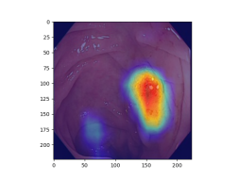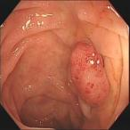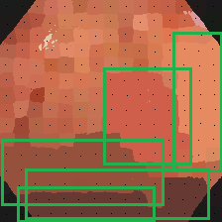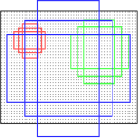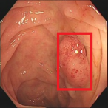

Binarizate

CAM

SSW

RPN

classifier

classifier

[Bilen *et al.*]

[Tang *et al*.]

[Zeng *et al.*]

**or**

[Ahn *et al.*]

[Li *et al*.]

[Kwon *et al.*]



Pedicle